MSDS-458 Assignment #2

Finding Natural Feature Sets

Mark McGown

* **Project Problem Statement**

Inferring behavior and actions from phone accelerometer data is an increasingly important area of interest, both to the users who want to know more about their own generalized behavior as well as to companies hoping to cater to that desire. The more accurate these predictions can be made, the more an endless list of possibilities are enabled including: hand-based gestures, patterns of movement when the user has the phone stored, signatures detected by process control systems, medical/fitness tracking, and structural monitoring. These potential applications pose an exciting opportunity for data mining, passive monitoring most importantly due to the wealth of data that can be collected while a user is performing other tasks. Accurate predictions in this way may passively allow interaction with a user’s phone that prevents calls during exercise, determine if there’s been a car accident to call for help, or simply knowing if a user who has walked upstairs may likely be asleep.

Complications arise with this strategy when two or more actions share similar patterns in accelerometer data. This might occur when such an algorithm is trying to distinguish a user who is going upstairs from a user who is going downstairs. Fortunately, current methods exist such as Long Short-Term Memory (LSTM) that may bring data from these similar actions into focus. Such methods may further grasp the context of the time-based nature for these specific sequences.

* **Data Set**

Accelerometer data from Fordham University’s Wireless Sensor Data Mining (WISDM) lab was used to measure the acceleration of various users performing 6 different tasks in the x,y, and z direction (Kwapisz, Moore, & Weiss, 2010). Sitting, walking, jogging, standing, going upstairs, and going downstairs were all the actions monitored on 36 different users. One instance of a user

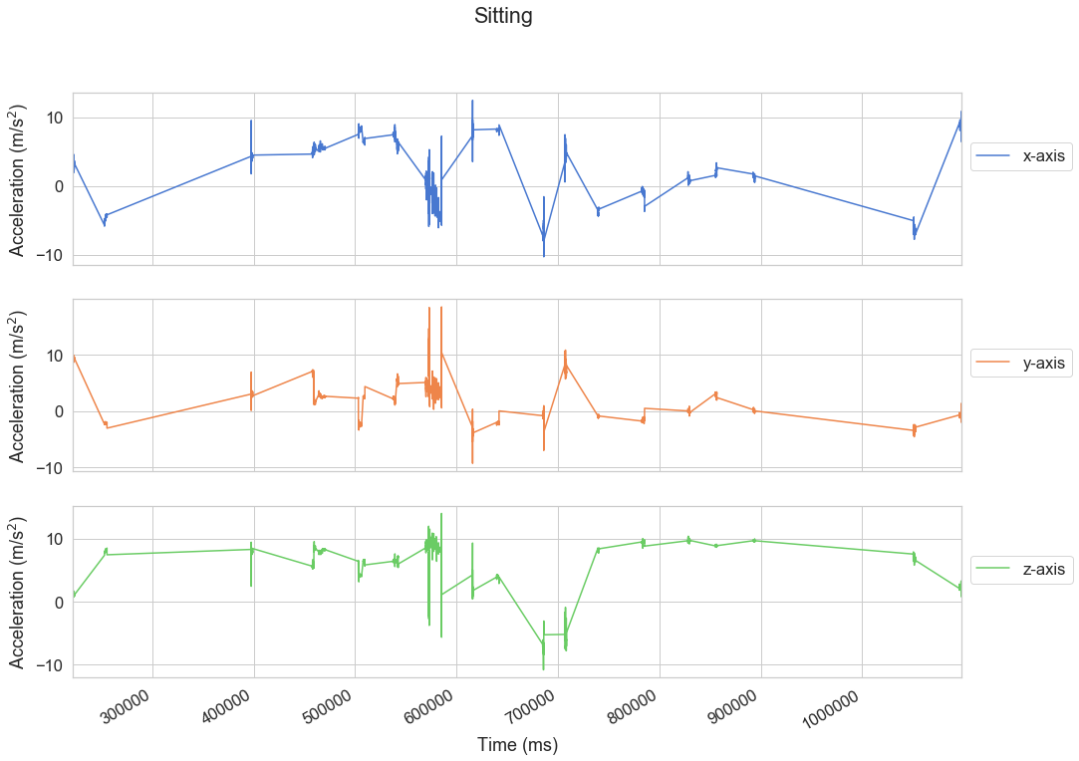

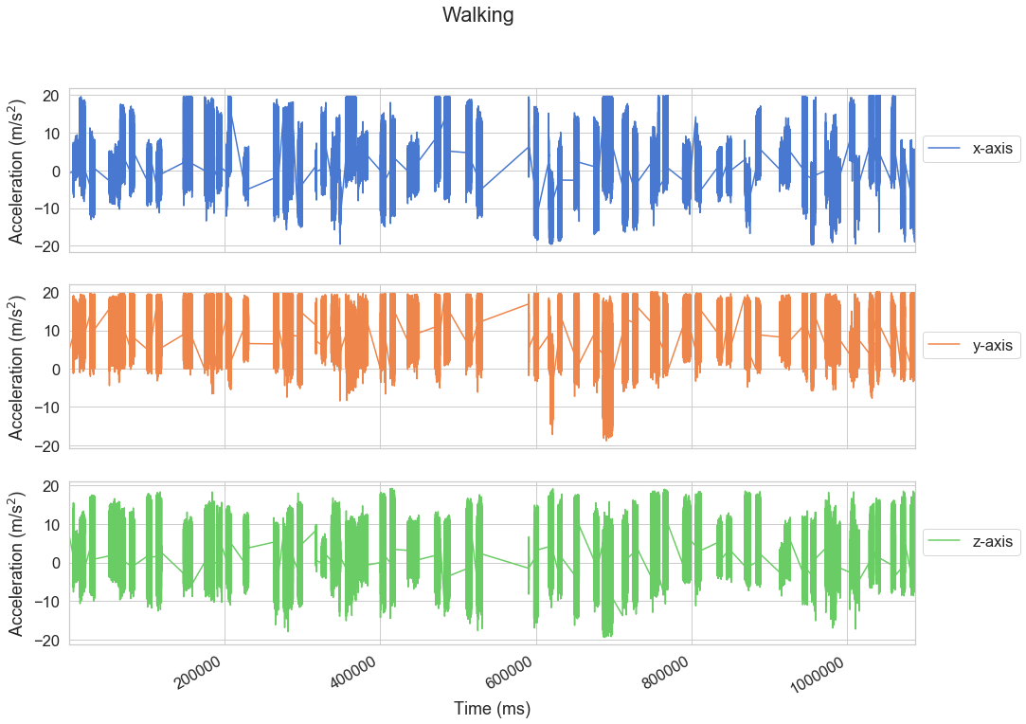

**References**

Kwapisz, J. R., Moore, S. A., & Weiss, G. M. (2010). Activity Recognition using Cell Phone

Accelerometers, Proceedings of the Fourth International Workshop on Knowledge Discovery from Sensor Data (at KDD-10), Washington DC. http://www.cis.fordham.edu/wisdm/includes/files/sensorKDD-2010.pdf